Subject: CH 101R1- Chemistry

Module I: Bonding in Coordination Complex (8 Lecture)
Introduction to Chemical Bonding, Werner's Theory, Bonding in coordination complexes, Crystal Field Theory, Octahedral, Tetrahedral and Square planar complexes, CFSE, Jahn Teller theorem, Spectral, electronic and magnetic properties of coordination complexes.

TYPES OF BONDS
Atoms may attain a stable electronic configuration in three different ways: by losing electrons, by gaining electrons, or by sharing electrons.
Elements may be divided into three types:
  - Electropositive elements, whose atoms give up one or more electrons readily.
- electronegative elements. which will accept electrons.
- Elements which have little tendency to lose or gain electrons.
Three different types of bond may be formed, depending on theelectropositive or electronegative character of the atoms involved.
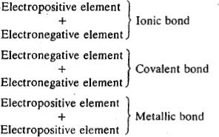

WERNER’S THEORY OF COORDINATION COMPOUNDS
The systematic study of coordination compounds was started by Alfred Werner whose pioneering work opened an entirely new field of investigation in inorganic chemistry. He prepared and characterized a large number of coordination compounds and studied their physical, chemical and isomeric behaviour by simple experimental techniques. On the basis of these studies, Werner, in 1898, propounded his theory of coordination compounds.

Table: Series of coloured compounds obtained by the interaction of aqueous CoCl₃ and NH₃
Compound Colour Name according to colour CoCl₃.6NH₃ Yellow Luteo Complex CoCl₃.5NH₃ Purple Purpureo Complex CoCl₃.4NH₃ Green Praseo Complex
CoCl₃.4NH₃ Violet Violeo Complex Isomers

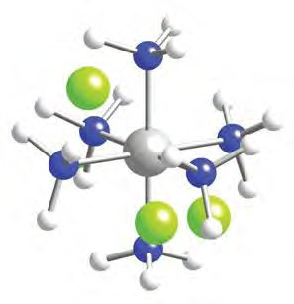
[Co(NH₃)₆]Cl₃

The main postulates of Werner’s theory are:
- metals exert two types of linkages; (i) the primary or ionizable links which are satisfied by negative ions and equal the oxidation state of the metal, and (ii) the secondary or nonionizable links which can be satisfied by neutral or negative ions/groups. The secondary linkages equal the coordinationnumber of central metal atom/ion. This number is fixed for a metal.
- the ions/groups bound by the secondary linkages have characteristic spatial arrangements corresponding to different co-ordination numbers. In the modern terminology, such spatial arrangements are called coordination polyhedra.

Ligands
The ligands are the ions or molecules bound to the central atom/ion in the coordination entity. This is better visualized as the combination of a Lewis acid (the central atom/ion) with a number of Lewis bases (ligands). The atom in the Lewis base that forms the bond to the Lewis acid (central atom/ion) is called donoratom (because it donates the pair of electrons required for bond formation). The central atom/ ion is the acceptor atom/ion (because it receives the electron pairs from the ligands). Some of the common ligands in coordination compounds are: Br–, Cl–, CN–, OH–, O^{2–}, CO₃^{2–}, NO₂–, C₂O₄^{2–}, NH₃, CO, H₂O,
NH₂CH₂CH₂NH₂ (1,2- ethanediamine). Ligands which can ligate through two different atoms present in it are called ambidentateligands. Examples of such ligands are the NO₂– and SCN– ions. NO₂– ion can coordinate through either the nitrogen or the oxygen atoms to a central metal atom/ion. Similarly, SCN– ion can coordinate through the sulphur or nitrogen atom. Such possibilities give rise to linkage isomerism in coordination compounds.

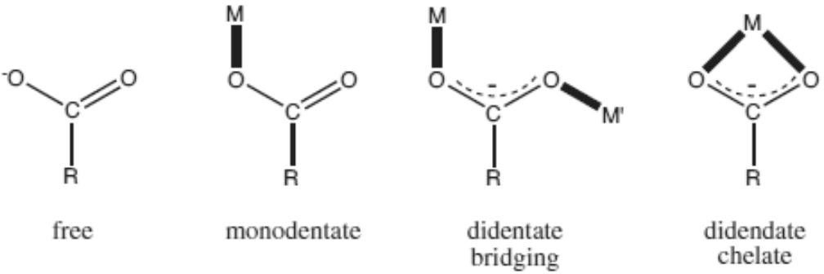

Figure:Metal ion binding options for a carboxylate group, featuring various monodentate and didentate coordination modes.

Types of ligands
Ligands can be classified as monodentate, bidentate, polydentate etc. ligands.

Monodentate ligand
This will coordinate to only site of a metal ion. In other words, it can donate only one pair of electrons to the metal ion.
Example: Cl-, Br-, SO42-, NH2NH3+, NH3, H2O

Bidentate ligand
This will occupy two sites of a metal ion. That is, it can attach itself to two positions of a metal ion.
Example: NH2CH2CH2NH2 etc

Polydentate ligands
These ligands occupy many sites of the same metal ion. Example: EDTA etc.
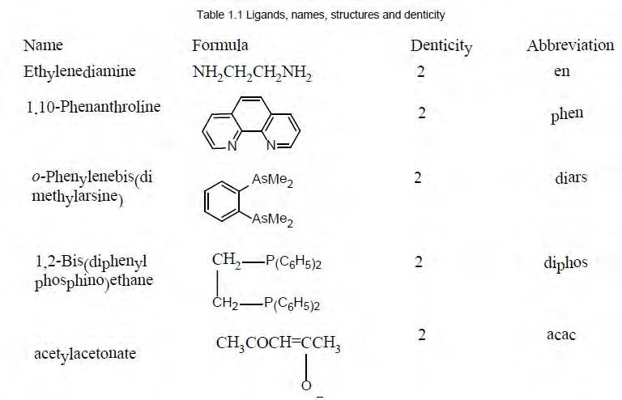

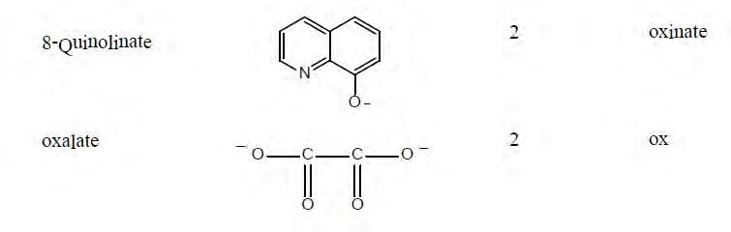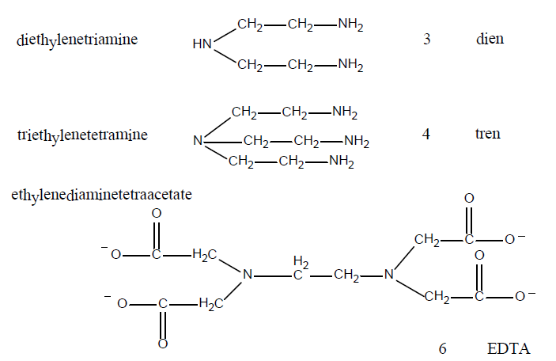

Isomerism in Coordination Compounds

Two or more different compounds having the same formula are called isomers. Two principal types of isomerism areknown among coordination compounds. Each of which can be further subdivided.

Stereoisomerism.
  - Geometrical isomerism
  - Optical isomerism

Structural Isomerism.
  - Coordination isomerism
  - Ionisation isomerism
  - Hydrate isomerism
  - Linkage isomerism

Some terms & their definitions:
Enantiomer: Stereoisomers which are not superimposable on their mirror images are called enantiomers.
Diastereoisomers: Stereoisomers which do not possess mirror image relation are called diastereoisomers.
Asymmetric molecule: A molecule without any symmetry (except c1) is classified as an Asymmetric molecule.

Geometric Isomerism: Geometric Isomers differ in the spatial arrangement of atoms within the same structural framework. It is also called cis- trans- isomerism.

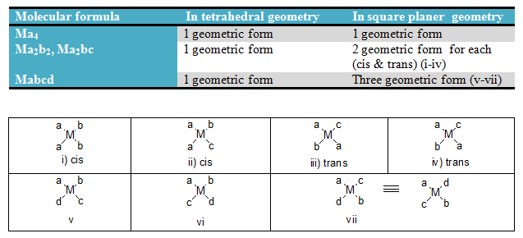
Geometric Isomerism for coordination no. 4

1. Geometric Isomerism for coordination no. 6:
2.
- Optical isomerism: A chiral complex is optically active if its structure can not be superimposed on its mirror image. The condition necessary for a molecule to exhibit Optical isomerism is the absence a rotation reflection axis(S_{n}).
- Easy judgement for optical activity implies the absence of plane or centre of symmetry.
- Q. How can you make an optically active square planer complexes? Give example.
6. Answer: Square planer complexes are generally optically inactive since the moleculer plane acts as a plane of symmetry. But optical isomerism may also appear in square planar complexes having an asymmetric ligand.

Geometric Isomerism for coordination no. 6
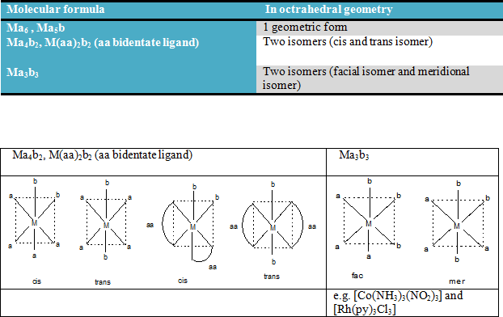

Optical isomerism: A chiral complex is optically active if its structure cannot be superimposed on its mirror image. The condition necessary for a molecule to exhibit Optical isomerism is the absence a rotation reflection axis (S_{n}).
Easy judgement for optical activity implies the absence of plane or centre of symmetry.

Q. How can you make an optically active square planer complexes? Give example.
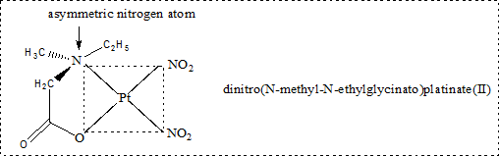
Answer: Square planer complexes are generally optically inactive since the moleculer plane acts as a plane of symmetry. But optical isomerism may also appear in square planar complexes having an asymmetric ligand.

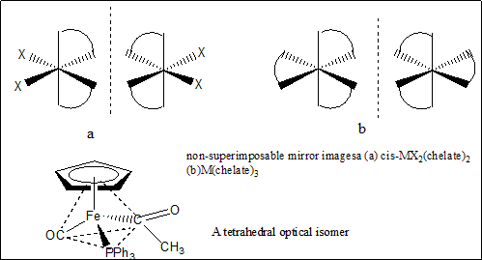

Structural Isomerism

Ionizotion Isomerism The ionization isomers [Co(NH₃)₅Br]SO₄ and [Co(NH)₅SO₄]Br dissolve in water to yield different ions and thus react differently to various reagents:

[Co(NH₃)₅Br]SO₄ + Ba²⁺ BaSO₄ (s)

[Co(NH)₅SO₄]Br + Ba²⁺ No reaction

[Co(NH₃)₅Br]SO₄+ Ag⁺ No reaction

[Co(NH)₅SO₄]Br + Ag⁺ AgBr(s)

Solvate Isomerism This is a somewhat special case or the above interchange of ligands involving neutral solvate molecules. The best known example involves isomers of "chromic chloride hydrates," of which three are known: [Cr(H₂O)₆]Cl₃, [Cr(H₂O)₅Cl]Cl₂.H₂O, and [Cr(H₂O)₄Cl₂]Cl.2H₂O, These differ in their reactions:

[Cr(H₂O)₆]Cl₃ [Cr(H₂O)₆]Cl₃ (no change)
dehydr. over H SO
2 4

[Cr(H₂O)₅Cl]Cl₂.H₂O [Cr(H₂O)₅Cl]Cl₂
dehydr. over H SO
2 4

[Cr(H₂O)₄Cl₂]Cl.2H₂O ^{dehydr.} ^{over} ^{H} ^{SO} [Cr(H₂O)₅Cl]Cl₂
2 4

Coordinotion Isomerism Coordination compounds made up of cationicand anionic coordination entities show this typeof isomerism due to the interchange of ligandsbetween the cation and anion entities. Some ofthe examples are:

(i) [Co(NH₃)₆][Cr(CN)₆] and[Cr(NH₃)₆][Co(CN)₆]
(ii) (ii) [Cu(NH₃)₄][PtCl₄] and [Pt(NH₃)₄] [CuCl₄]

Such isomers are expected to havesignificant differences in their physical andchemical properties.

A special case of coordination isomerism has sometimes been given the name "polymerization isomerism" since the various isomers differ in formula weight from one another, However, the term is unfortunate since polymerization is normally used to refer to the reaction in which a monomeric unit builds a larger structure consisting of repeating units. The isomers in question are represented by compounds such as [Co(NH)₄(NO₂)₂][Co(NH₃)₂(NO₂)₄, [Co(NH₃)₆][Co(NO₂)₆], [Co(NH₃)₅NO₂]
[Co(NH₃)₂(NO₂)₄]₂,etc. These all have the empirical formula Co(NH₃)₃(NO₂)₃, but they have formula weights that are 2,2, and 3, times this, respectively.

Linkage isomerism
Linkage isomerism occurs with ambidentate ligands. These ligands are capable of coordinating in more than oneway. The best known cases involve the monodentate ligands SCN- / NCS- and NO2- / ONO-.

For example:
[Co(NH₃)₅ONO]Cl the nitrito isomer -O attached [Co(NH₃)₅NO₂]Cl the nitro isomer - N attached.

Other Types of Isomerism

Ligand Isomerism Since many ligands are organic compounds which have possibilities for isomerism, the resulting complexes can show isomerism from this source. Examples of isomeric ligands are 1,2-diaminopropane ("propylenediamine," pn) and 1,3-diaminopropane ("trimethylenediamine," tn) or orlho-, meta-, and para-toluidine (CH₃C₆H₄NH₂).

Bonding Theories

Various theoretical approaches to the electronic structure of coordination complexes have been developed. We will discuss some of these bonding models.

Valence Bond Theory

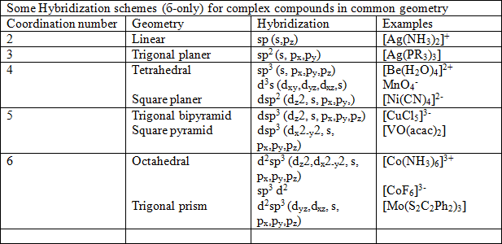
From the valence bond point of view, formation of a complex involves reaction between Lewis bases (ligands) and a Lewis acid (metal or metal ion) with the formation of coordinate covalent
(or dative bonds between them, The model utilizes hybridization of metal s, p. and d valence orbitals to account for the observed structures and magnetic properties of complexes, For example, complexes of Pd(II) and Pt(II) are usually four-coordinate. square planar, and diamagnetic. and this arrangement is often found for Ni(II) complexes as well. Inas much as the free ion in the ground state in each case is paramagnetic (d⁸), the bonding picture has toinclude pairing of electrons as well as ligand-melal-ligand bond angles of 90°. Pauling suggested this occurs via hybridization of one (n-1)d, the ns and two nporbilals to form four equivalent dsp² hybrids directed toward the corners of a square. These orbitals then participate in covalent σ bonds with the ligand, the bonding electron pairs being furnished by the ligands. The eight electrons that were distributed among the five d orbitals in the free ion are assigned as pairs to the four unhybridized metald orbitals.
With some ligands, such as CI⁻, Ni(II) forms four-coordinate complexes that are parnmagnetic and tetrahedral. For these cases, VB theory assumes the d orbital occupation of the complex to be the same as that of the free ion, which eliminates the possibility that valence-level d orbitals can accept electron pairs from the ligands. Hybrid orbitals of either

the sp³ or sd³ type (the latter involving n-level d orbitals) or a combination of the two provide the proper symmetry for the σ bonds as well as allowing for the magnetic properties.
The valence bond picture for six-coordinate octahedral complexes involves d²sp³hybridization of the metal. The specific d orbitals that meet the symmetry requirements for the metal-ligand σ bonds are the d ² and d ² ². As with the four-coordinate d⁸ complexes discussed above: the presence of unpaired electrons in some octahedral compounds renders the valence level (n-1)d orbitals unavailable for bonding. This is true, for instance, for paramagnetic [CoF₆]³⁻. In these cases, the VB model invokes participation of n-level d orbitals in the hybridization.
z x -y
Examples
In the diamagnetic octahedral complex, [Co(NH₃)₆]³⁺, the cobalt ion is in +3 oxidation state and has the electronic configuration 3d6. The hybridisation scheme is as shown in diagram. Six pairs of electrons, one from each NH3 molecule, occupy the six hybrid orbitals. Thus, the complex has octahedral geometry and is diamagnetic because of the absence of unpaired electron. In the formation of this complex, since the inner d orbital (3d) is used in hybridisation, the complex, [Co(NH₃)₆]³⁺ is called an inner orbital or low spin or spinpaired complex.
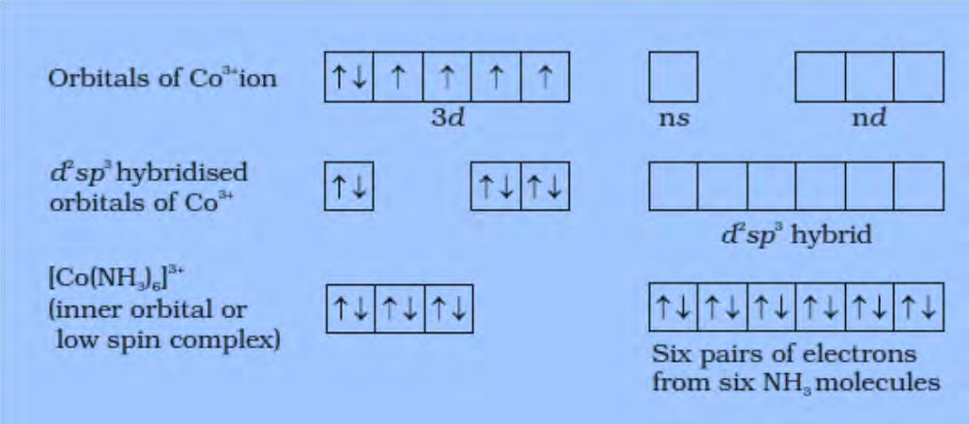

The paramagnetic octahedral complex, [CoF₆]^{3–} uses outer orbital (4d) in hybridisation (sp³d²). It is thus called outer orbital or high spin or spin free complex. Thus:
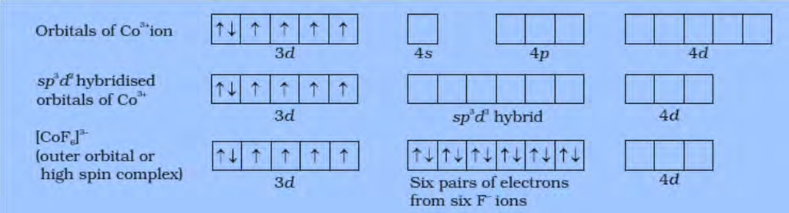

In tetrahedral complexes one s and three p orbitals are hybridised to form four equivalent orbitals oriented tetrahedrally. This is illustrated below for [NiCl₄]²⁻. Here nickel is in +2 oxidation state and the ion has the electronic configuration 3d⁸. The hybridisation scheme is as shown in diagram. Each Cl– ion donates a pair of electrons. The compound is paramagnetic since it contains two unpaired electrons. Similarly, [Ni(CO)₄] has tetrahedral geometry but is diamagnetic since nickel is in zero oxidation state and contains no unpaired electron.
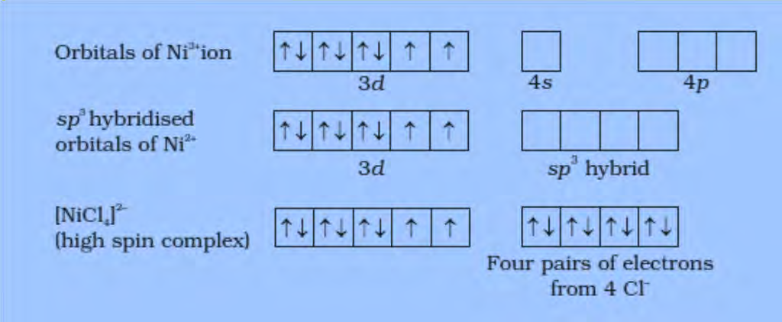

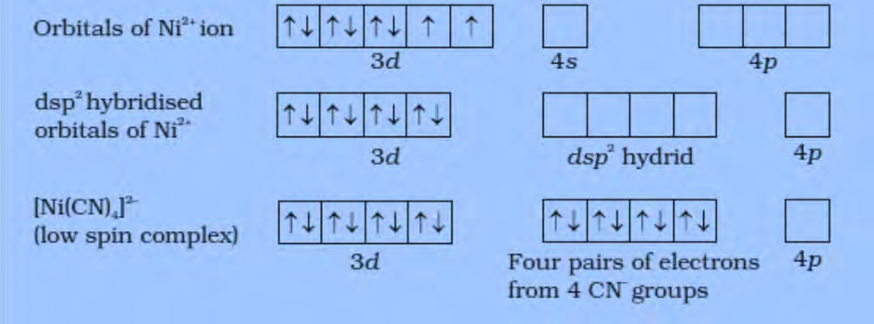
In the square planar complexes, the hybridisation involved is dsp². An example is [Ni(CN)₄]₂. Here nickel is in +2 oxidation state and has the electronic configuration 3d⁸. The hybridisation scheme is as shown in diagram:
Each of the hybridised orbitals receives a pair of electrons from a cyanide ion. The compound is diamagnetic as evident from the absence of unpaired electron. It is important to note that the hybrid orbitals do not actually exist. In fact, hybridisation is a mathematical manipulation of wave equation for the atomic orbitals involved.

Limitation of the VBT:
- Fail to explain the colour & characteristics of absorption spectra of complex compounds.
- Orbital contribution and temperature dependency on magnetic moment of coordination complex are not properly explained by VBT.

- It is not helpful to predict the mystery of formation of outer or inner orbital coordination complex.
- VBT fails to predict any distortion in the shapes of the coordination complexes from regular geometry.

Crystal Field Theory

Crystal field theory was originally developed to describe the electronic structure of metal ions in crystals, where they are surrounded by anions that create an electrostatic field with symmetry dependent on the crystal structure. The energies of the d orbitals of the metal ions are split by the electrostatic field, and approximate values for these energies can be calculated. No attempt was made to deal with covalent bonding, because covalency was assumed nonexistent in these crystals. Crystal field theory was developed in the 1930s.Shortly afterward, it was recognized that the same arrangement of electron-pair donorspecies around a metal ion existed in coordination complexes as well as in crystals, anda more complete molecular orbital theory was developed. However, neither was widelyused until the 1950s, when interest in coordination chemistry increased.
When the d orbitals of a metal ion are placed in an octahedral field of ligand electron pairs, any electrons in these orbitals are repelled by the field. As a result, the d_{z}² and d_{x}²_{-y}² orbitals, which have e_{g} symmetry, are directed at the surrounding ligands and are raisedin energy. The d_{xy}, d_{xz} and d_{yz} orbitals (t_{2g} symmetry), directed between the ligands, arerelatively unaffected by the field. The resulting energy difference is identified as Δ_{o} (o foroctahedral; older references use l0 Dq instead of Δ_{o}). This approach provides anelementary means of identifying the d-orbital splitting found in coordination complexes.
The average energy of the five d orbitals is above that of the free ion orbitals, because the electrostatic field of the ligands raises their energy. The t_{2g} orbitals are 0.4Δ_{o} below and the e_{g}orbitals are 0.6 Δ_{o} above this average energy, as shown in Figure 2. The threet_{2g} orbitals then have a total energy of — 0.4Δ_{o} X 3 = — 1.2Δ_{o} and the two e_{g} orbitalshave a total energy of +0.6Δ_{o} X 2 = +1.2Δ_{o} compared with the average. The energy difference between the actual distribution of electrons and that for the hypotheticalconfiguration with all electrons in the uniform (or spherical) field level is called the crystal field stabilization energy (CFSE). The CFSE quantifies the energy difference between theelectronic configurations due to (1) the d orbitals experiencing an octahedral ligand fieldthat discriminates among the d orbitals, and
(2) the d orbitals experiencing a spherical fieldthat would increase their energies uniformly.

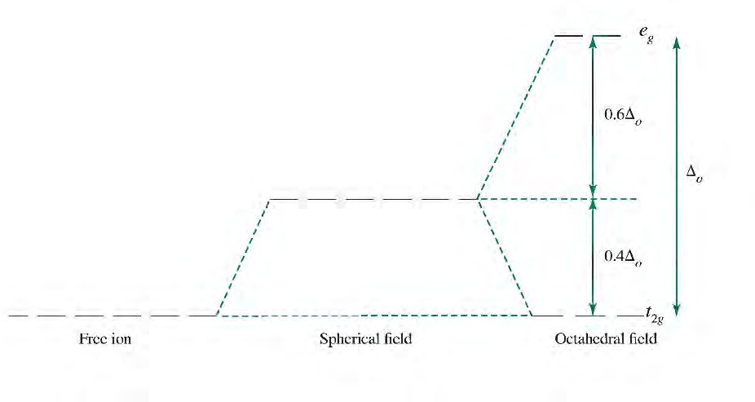
This model does not rationalize the electronic stabilization that is the driving force for metal ligand bond formation. As we have seen in all our discussions of molecular orbitals, any interaction between orbitals leads to formation of both higher and lower energy molecular orbitals, and bonds form if the electrons are stabilized in the resulting occupied molecularorbitals relative to their original atomic orbitals. On the basis of Figure 2, the electronic energy of the free ion configuration can at best be unchanged in energy upon the free ion interacting with an octahedral ligand field; the stabilization resulting from the metal ion interacting with the ligands is absent. Because this approach does not include the lower (bonding) molecular orbitals, it fails to provide a complete picture of the electronic structure.
Figure 2: Crystal Field Splitting

Octahedral complexes:
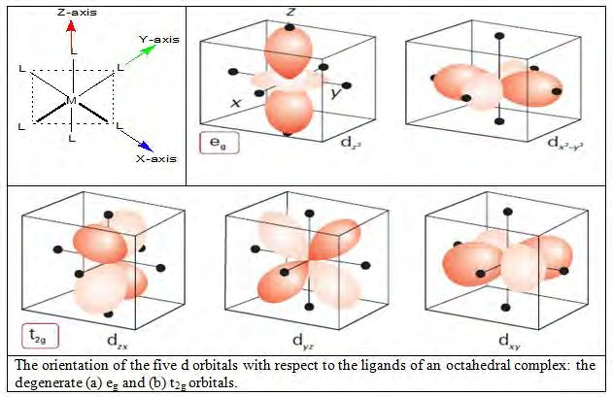

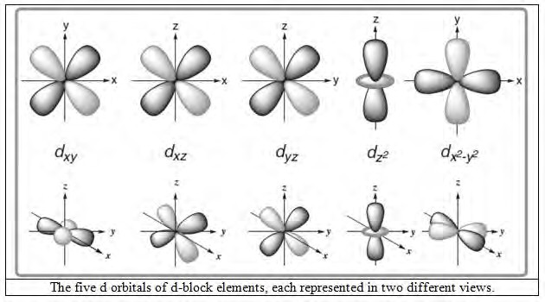

In an octahedral field those d orbital whose lobes are directed along the axis will experience
greater interaction from the point charges placed in those directions. These are the d ² ² and
x −y
d ² orbitals- the electron of these orbital will experience stronger repulsion from the point charges in the environment i.e. these orbitals will be destabilized & their energy will be raised to some extent.
z

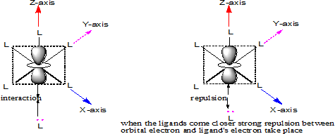

But the remaining three orbital d_{xy}, d_{xz} and d_{yz} have their lobes between the axes (45°) and will be less effected by the point charges in the environment i.e. these orbitals will be subject less electronic repulsion and to maintain the barycentre or center of gravity, energy of these orbitals will be lowered some extent.The splitting pattern of d orbitals in octahedral field:

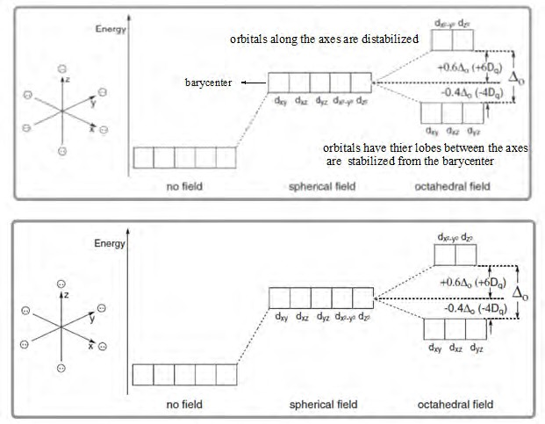

The separation between the t_{2g} and e_{g} levels is conventionally represented by Δ° or 10 Dq.

Tetrahedral Complexes
In tetrahedral coordination entity formation, the d orbital splitting (Fig. 3) is inverted and smaller as compared to the octahedral field splitting. For the same metal, the same ligands and metal-ligand distances, it can be shown that Δ_{t}= –(4/9)Δ_{o}. Consequently, the orbital splitting energies are not sufficiently large for forcing pairing and, therefore, low spin configurations are rarely observed.
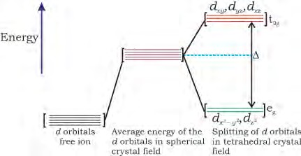
Figure 3.d orbital splitting in a tetrahedral crystalfield.

Square Planar Complexes
If two trans ligands in an octahedral ML₆ complex (for example those along the z axis) are moved either towards or away from the metal ion, the resulting complex is said to be tetragonally distorted. Ordinarily such distortions are not favored since they result in a net loss of bonding energy. In certain situations, however, such a distortion is favored because of a Jahn- Teller effect (explained later). A complex of general formula trans-MA₂B₄ also will have tetragonal (D 4h ) symmetry. For now, we will merely consider the limiting case of tetragonal elongation, a square planar ML₄ complex, for the purpose of deriving its d orbital splitting pattern.Figure 4 illustrates the effect of z-axis stretching on the e_{g} and t_{2g} orbitals in an octahedral complex, Orbitals having a Z component (the d_{xz}, d_{yz} and d ² ) will experience a decrease in electrostatic repulsions from the ligands and will therefore be stabilized, At the same time, the "non-z" orbitals will be raised in energy, with the barycenter remaining constant. The overall result is that the e_{g} level is split into two levels. an upper b_{1g} (d ² ²) and
z
x –y
2g
2g
xy
g
xz
yz

a lower a_{1g} (d ²) and the t
z
set is split into a b
(d ) and a doubly degenerate e
(d , d ).

The energy spacing between the b_{2g} and b_{1g} levels is defined as Δ. As in the octahedral case, this splitting is equal to 10Dq.
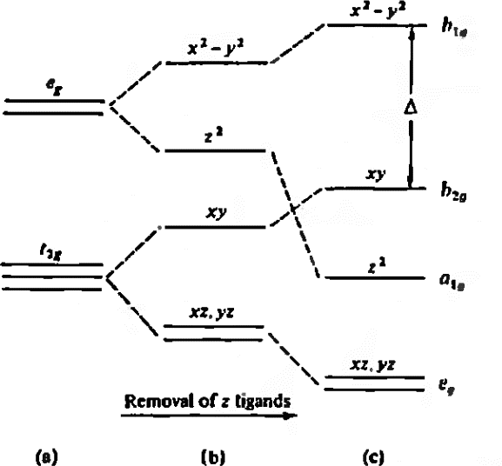
The square planar geometry is favored by metal ions having a d⁸ configuration in the presence of a strong field, This combination gives low spin complexes with the eight d electrons occupying the low-energy d_{xz}, d_{yz}, d ² and d_{xy} orbitals, while the high-energy d ² y²orbital remains unoccupied. The stronger the surrounding field, the higher the d ² ² orbital will be raised. As long as this level is unoccupied, however, the overall effect on the complex will be stabilization because the lower, occupied orbitals will drop in energy by a corresponding amount. Typical low spin square planar complexes are [Ni(CN₄)]^{2–}, [PdCI ₄]^{2–}, [Pt(NH₃)₄]²⁺, [PtCl₄]^{2–}, and [AuCl₄]–, all d⁸ species.
z x –
x –y
Figure 4. An octahedral complex (a) undergoing z axis elongation such that it becomes tetragonally distorted (b) and finally reaches the square planar limit (c).

Crystal field stabilization energy:
The crystal field stabilization energy (CFSE) is the stability that results from placing a transition metal ion in the crystal field generated by a set of ligands. It arises due to the fact that when the d -orbitals are split in a ligand field (as described above), some of them become lower in energy than before with respect to a spherical field known as the bary-center in which all five d -orbitals are degenerate. For example, in an octahedral case, the t_{2g} set becomes lower in energy than the orbitals in the bary-center. As a result of this, if there are any electrons occupying these orbitals, the metal ion is more stable in the ligand field relative to the bary-center by an amount known as the CFSE. Conversely, the e_{g} orbitals (in the octahedral case) are higher in energy than in the bary-center, so putting electrons in these reduces the amount of CFSE.
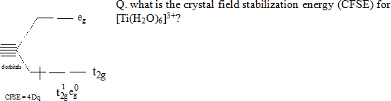

The only one d electron of Ti³⁺ will occupy the lowest available orbital & it is stabilized by the energy 4 Dq.
Q. what will be the electron arrangement for d⁴ and more than d⁴ conformation? Answer: This splitting is affected by the following factors:
- the nature of the metal ion.
- the metal's oxidation state. A higher oxidation state leads to a larger splitting.
- the arrangement of the ligands around the metal ion.
- the nature of the ligands surrounding the metal ion. The stronger the effect of the ligands then the greater the difference between the high and low energy d groups.
There are two possibilities for these type of cases: e.g. for d⁴ case

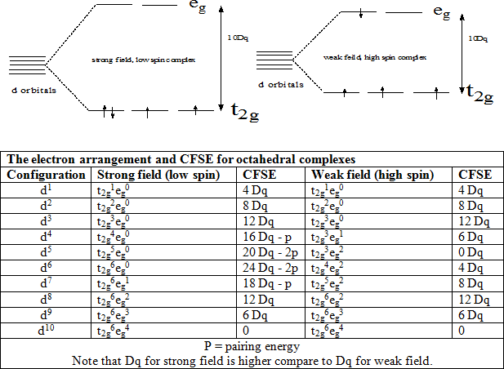

Crystal field theory and molecular orbital theory were combined into ligand field theory by Griffith and Orgel.

Effect of ligands on d orbital splitting (spectrochemical series):
The ligands are sequencing according to their splitting ability, strong field ligand split the d orbitals more ( i. e . the separation between t 2g and e g is large) compare to weak field ligand and form low-spin complex where as weak field ligand form high spin complex.

Spinels
The d-block higher oxides Fe₃O₄, Co₃O₄, and Mn₃O₄, and many related mixed-metal compounds, such as ZnFe₂O₄, have very useful magnetic properties. They all adopt the structural type of the mineral spinel, MgAl₂O₄, and have the general formula AB2O4. Most oxide spinels are formed with a combination of A²⁺ and B³⁺cations (that is, as A²⁺ B₂³⁺O₄ in Mg²⁺[Al³⁺]₂O₄), although there are a number of spinels that can be formulated with A⁴⁺ and B²⁺cations (as A⁴⁺B₂²⁺O₄ as in Ge⁴⁺[Co²⁺]₂O₄. The spinel structure consists of an fcc array of O^{2–} ions in which the A ions reside in one-eighth of the tetrahedral holes and the B ions inhabit half the octahedral holes (Fig. 5); this structure is commonly denoted A[B₂]O₄, where

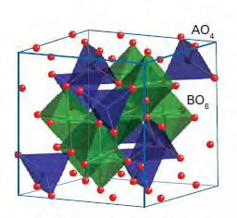
the atom type in the square bracket represents that occupying the octahedral sites. In the inverse spinel structure, the cation distribution is B[AB]O₄, with the more abundant B-type cation distributed over both coordination geometries. Lattice enthalpy calculations based on a simple ionic model indicate that, for A²⁺ and B³⁺, the normal spinel structure, A[B₂]O₄, should be the more stable. The observation that many d-metal spinels do not conform to this expectation has been traced to the effect of crystal-field stabilization energies on the site preferences of the ions.
Figure 5. A segment of the spinel(AB₂O₄) unit cell showing the tetrahedralenvironment of A ions and the octahedralenvironments of B ions.

The occupation factor, λ, of a spinel is the fraction of B atoms in the tetrahedral sites: λ = 0 for a normal spinel and λ = ½ for an inverse spinel, B[AB]O₄; intermediate λvalues indicate a level of disorder in the distribution, where B-type cations occupy that portion of the tetrahedral sites. The distribution of cations in (A²⁺, B³⁺) spinels (Table 3) illustrates that for d⁰ A and B ions the normal structure is preferred as predicted by electrostatic considerations. Table 3 shows that, when A²⁺ is a d⁶, d⁷, d⁸, or d⁹ ion and B³⁺ is Fe³⁺, the inverse structure is generally favoured. This preference can be traced to the lack of crystal-field stabilization of the high-spin d⁵ Fe³⁺ ion in either the octahedral or the tetrahedral site and the ligand-field stabilization of the other d^{n}ions in the octahedral site. For other combinations of d-metal ions on the A and B sites the relative ligand-field stabilization energies of the different arrangements of the two ions on the octahedral and tetrahedral sites need to be calculated. It is also important to note that simple ligand-field stabilization appears to work over this limited range of cations.
More detailed analysis is necessary when cations of different radii are present or any ions that are present do not adopt the high-spin configuration typical of most metals in spinels (for instance, Co³⁺ in Co³O⁴, which is low-spin d⁶). Moreover, because λis often found to depend on the temperature, care has to be taken in the synthesis of a spinel with a specificdistribution of cations because slow cooling or quenching of a sample from a high reaction temperature can produce quite different cation distributions.

Table 3. Occupation factor, λ, in some spinels.
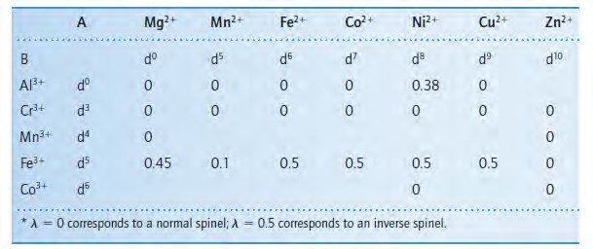

The inverse spinels of formula AFe₂O₄ are sometimes classified as ferrites (the same term also applies in different circumstances to other iron oxides). The compound CoAl₂O₄ is among the normal spinels in Table 3 with λ = 0 and thus has the Co²⁺ ions at the tetrahedral sites. The colour of CoAl₂O₄ (an intense blue) is that expected of tetrahedral Co²⁺. This property, coupled with the ease of synthesis and stability of the spinel structure, has led to cobalt aluminate being used as a pigment (‘cobalt blue’). Other mixed d-metal spinels that exhibit strong colours, for example CoCr₂O₄ (green), CuCr₂O₄ (black), and (Zn,Fe)Fe₂O₄ (orange/brown), are also used as pigments, with applications that include colouring various construction materials, such as concrete.
EXAMPLEPredicting the structures of spinel compounds
Q Is MnCr2O4 likely to have a normal or inverse spinel structure?
Answer We need to consider whether there is a ligand-field stabilization. Because Cr³⁺ (d³) has a large ligand-field stabilization energy (1.2Δ_{O}) in the octahedral site (but a much smaller one in a tetrahedral field) whereas the high spin d⁵ Mn²⁺ ion does not have any LFSE, a normal spinel structure is expected. Table 3 shows that this prediction is verified experimentally.

The Jahn-Teller Effect
The Jahn-Teller theorem states that degenerate orbitals (those with identical energies) cannot be unequally occupied. To avoid these unfavorable electronic configurations, molecules distort (lowering their symmetry) to render these orbitals no longer degenerate. For example,

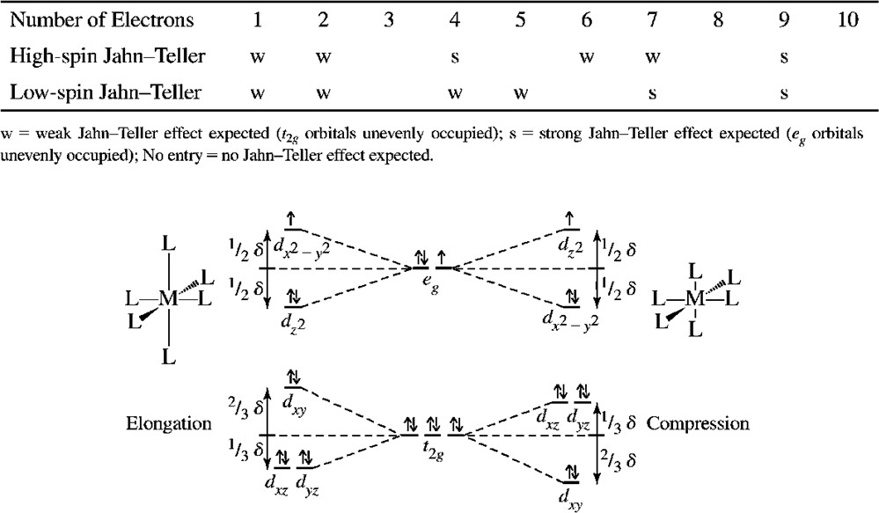
an octahedral Cu(II) complex, containing a d⁹ ion, would have three electrons in the two e_{g} levels, as in the center of Figure 6, but an octahedral structure is not observed. Instead, the shape of the complex changes slightly, resulting in changes in the energies of the orbitals that would be degenerate within an octahedral ligand environment. The resulting distortion is usually elongation along one axis, but compression along one axis is also possible. In ideally octahedral complexes that experience Jahn-Teller distortion, the (formally) e* orbitals change more in energy relative to the (formally) t_{2g}orbitals. More significant Jahn-Teller distortions occur when e* orbitals would be unequally occupied within an octahedral geometry. Much more modest distortions, sometimes difficult to observe experimentally, occur to prevent unequal occupation of t_{2g} orbitals within an octahedral geometry. The general effects of elongation and compression on d-orbital energies are shown in Figure 7, and the expected degrees of Jahn-Teller distortion for different electronic configurations and spin states are summarized in the following table:

Figure 7. Jahn-Teller Effect on a d⁹ Complex. Elongation along the z axis is coupled with a slight decrease in bond length for the other four bonding directions. Similar changes in energy result when the axial ligands have shorter bond distances. The resulting splits are larger for the e_{g} orbitals than for thet_{2g}orbitals.The energy differences are exaggerated in this figure.

Significant Jahn-Teller effects are observed in complexes of high-spin Cr(II) (d⁴), high-spin Mn(III) (d⁴), Cu(II) (d⁹), Ni(III) (d⁷), and low-spin Co(II) (d⁷). Low-spin Cr(II) complexes feature tetragonal distortion. Cu(II) complexes generally exhibit significant Jahn-Teller

effects; the distortion is most often elongation of two bonds. Elongation, which results in weakening of some metal- ligand bonds, also affects equilibrium constants for complex formation. For example, trans-Cu(NH₃)₄(H₂O)₂]²⁺ is readily formed in aqueous solution as a distorted octahedron with two water molecules at greater distances than the ammonia ligands; liquid ammonia is the required solvent for [Cu(NH₃)₆]²⁺ formation. The formation constants for these reactions show the difficulty of putting the fifth and sixth ammonias on the metal:
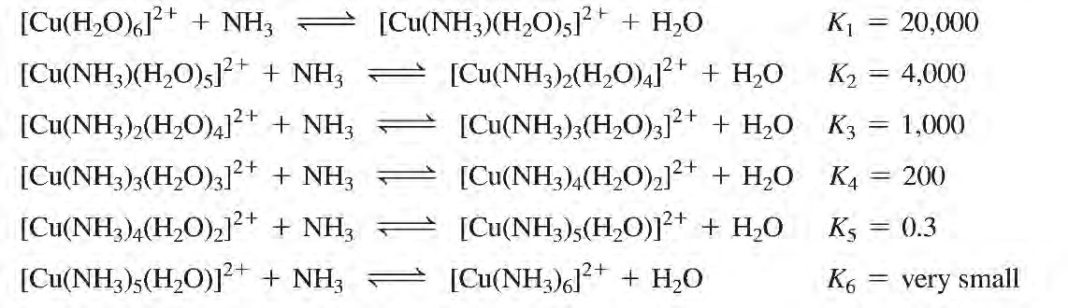

Which factor is the cause and which the result is uncertain, but the bottom line is that octahedral Cu(II) complexes are difficult to synthesize with some ligand sets because the bonds to two trans ligands in the resulting complexes are weaker (longer) than the other bonds to the ligands. In fact, many Cu(II) complexes have square-planar or nearly square- planar geometries, with tetrahedral shapes also possible. [CuCl₄]^{2–} exhibits cation-dependent structures ranging from tetrahedral through square planar to distorted octahedral.

Magnetic properties:
A brief knowledge is required for understanding the electronic spectroscopy of transition metal complexes. Additional and complementary information can be provided by magnetic measurement because for the partially filled d or orbitals of transition metal, a range of magnetic properties can be expected, depending on the oxidation state, electronic configuration and coordination number of the central metal.

Classification of substance according to magnetic properties:
Diamagnetism: When any substance is placed in an external magnetic field, there is an induced circulation of electrons producing a net magnetic moment aligned in opposition to the applied field. This is the diamagnetic effect and it arises from paired electrons within a sample, since all compounds contain some paired electrons, diamagnetism is a universal property of matter. If a substance has only paired electrons, this effect will dominate, the material will be classified as diamagnetic, and it will be slightly repelled by a magnetic field.

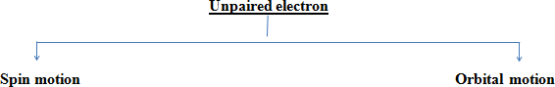
Paramagnetism: It is produced by unpaired electrons in a sample. The spins and orbital motions of these electrons give rise to permanent molecular magnetic moments that tend to align themselves with an applied field, Because it is much larger than the diamagnetic effect, the paramagnetic effect cancels any repulsions between an applied field and paired electrons in a sample, Thus even substances having only one unpaired electron per molecule will show a net attraction into a magnetic field. The paramagnetic effect is observed only in the presence of an external field.

There are three possible modes of coupling between those components: spin-spin, orbital- orbital and spin-orbital. For some complexes, particularly those of the lanthanides, we must consider all three types of coupling. The theoretical paramagnetic moment for such a complex is given by

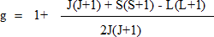
Where J is the total angular momentum quantum number and g is the L and splitting factor for the electron, defined as
The value of J depends on the total orbital angular momentum quantum number L and the total spin angular momentum quantum number S.
Magnetic properties of some compound of lanthanides metals at room temperature (300 K).
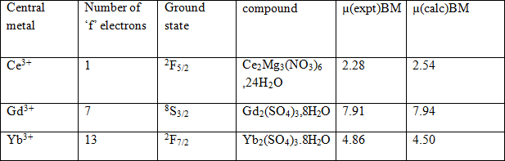
µ(calculated) B.M. is calculated by µ= g[J(J + 1)]^{½} formula

For complexes in which spin-orbit coupling is non-existent or negligible but spin and orbital contributions are both significant, the predicted expression for µ is

When the orbital contribution is minimal and could be ignored. Hence, L = 0 and in this condition, the previous equation reduces to

µ= [4S(S + 1)]^{½} = 2[S(S + 1)]^{½} BM
This is known as the spin-only formula for magnetic moment. By recognizing that S will be related to the number of unpaired electrons (II) by S = n/2, the expression may be further simplified to

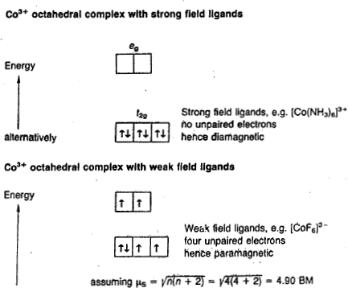
µ = [n(n + 2)]^{½} BM

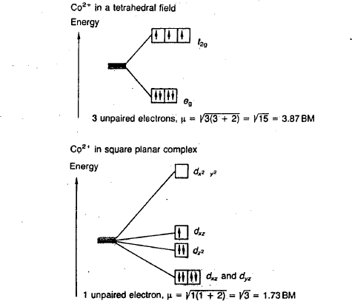

Special case of Copper acetate monohydrate, Cu(CH₃COO)₂.2H₂O
Copper (II) acetate monohydrate exists as a dimer and its structure is shown in fig. 6. The magnetic moment of the compound is only 1.43 BM which is less than the normal value of
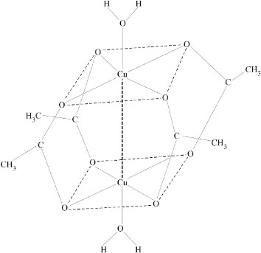
1.75 – 2.2 BM for one unpaired electron. This suggests some weak coupling of spins of unpaired electrons on the two copper atoms in the dimeric structure. In its structure, the acetate groups act as bidentate bridging groups between the two copper atoms. Therefore, each copper atom is surrounded by four oxygen atoms in a square planar arrangement. The fifth position around each Cu atom is occupied by the oxygen atom from a water molecule. The other copper atom occupies the sixth of the octahedral positions.

Figure 6. Structure of dimeric Cu (II) acetate monohydrate.

Electronic Spectra of Transition Metal Complexes

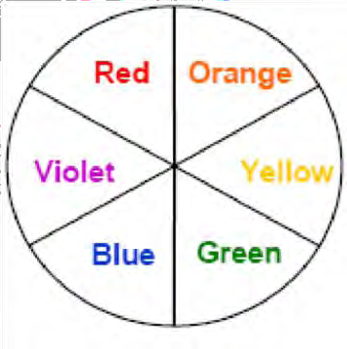
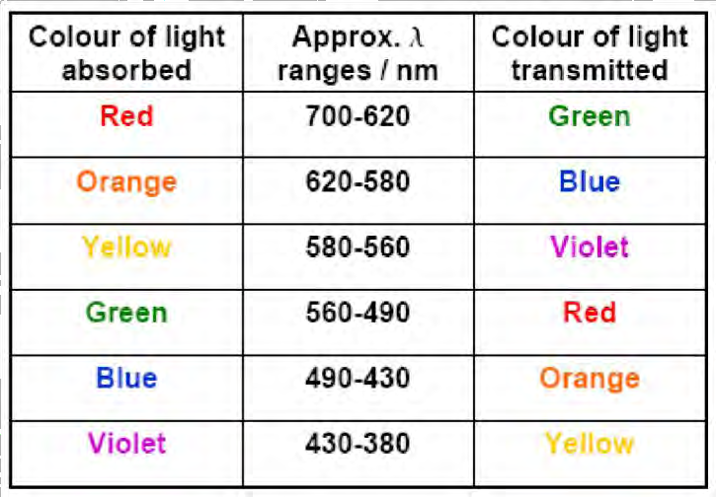
For example: If red is absorbed, the complex appears green.

The variety of colors among transition metal complexes has long fascinated the observer. For example, aqueous solutions of octahedral [Co(H₂O)₆]²⁺ are pink but those of tetrahedral [CoCl₄]^{2–}are blue. The green color of aqueous [Ni(H₂O)₆]²⁺turns blue when ammonia is added to the solution to give [Ni(NH₃)₆])²⁺. The reduction of violet [Cr(H₂O)₆]³⁺ gives bright blue [Cr(H₂O)₆]²⁺. As with all colors, these arise from electronic transitions between levels whose spacings correspond to the wavelengths available in visible light.(Of course, when a photon of visible light is absorbed. it is its complementary color that we actually see.) In complexes. these transitions are frequently referred to as d-d transitions because they involve the molecular orbitals that are mainly metal d in character (the e_{g} and t_{2g} or e and t₂ orbitals in octahedral and tetrahedral complexes, respectively), Obviously, the colors produced are intimately related to the magnitude of the spacing between these levels, Since this spacing depends on factors such as the geometry of the complex, the nature of the ligands present, and the oxidation state of the central metal atom, electronic spectra of complexes can provide valuable information related to bonding and structure.
The variation in the color of the Cr(III) complexes can be explained following similar argument.

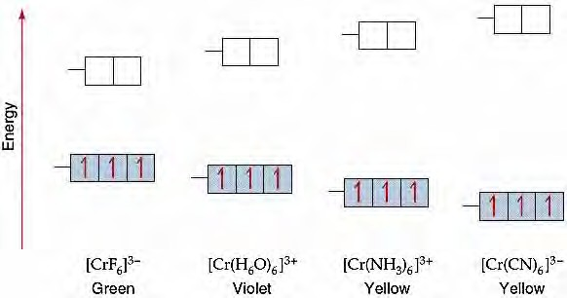
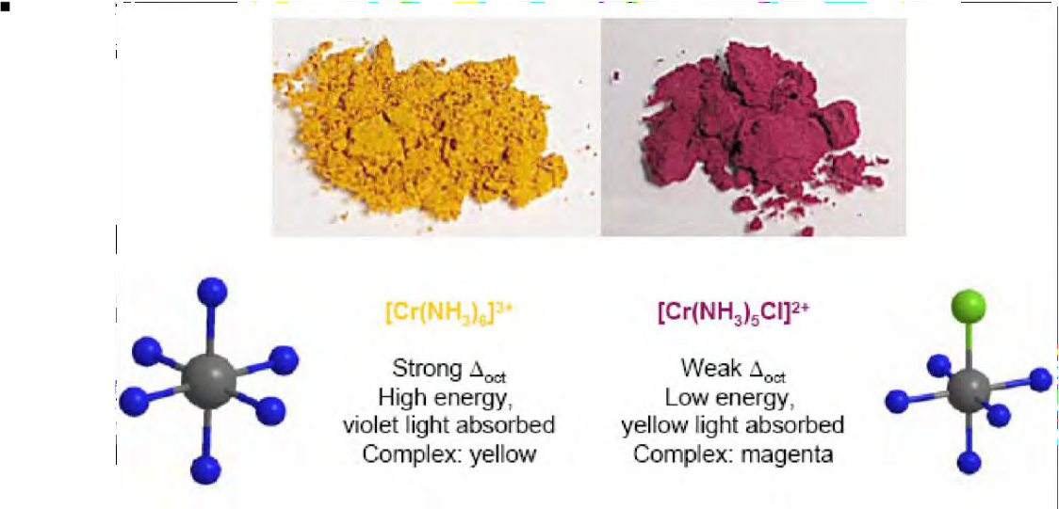

We observe the appearance of a shoulder in the case of [Ti(H₂O)₆]³⁺. Perfectly octahedral [Ti(H₂O)₆]³⁺ should give only one d-d Transition. However, distortion occurs to eliminate the degeneracy of the system. If a complex distorts from regular octahedral geometry, the t_{2g} and e_{g} levels are split, the consequence of which is the appearance of a shoulder as shown in the figure right.

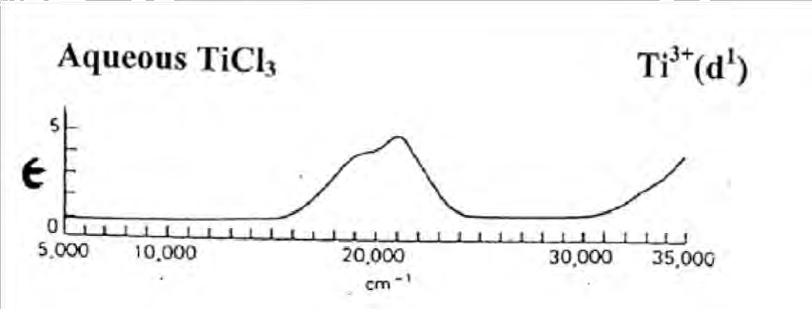

Complexes that contain metal ions of d¹⁰ electron configuration are usually colorless. Examples are [Cu(PPh₃)₄]⁺ and [Zn(H₂O)₆]²⁺. One would expect a metal complex with no d-eletron to be colorless as well. However, a few of such complexes are strongly colored, for example, MnO₄⁻ or [Cr₂O₇]²⁻. The origin of the color in these complexes is not the d-d transitions, rather due to ‘charge transfer’ that we will briefly discuss later.

Multi-electron systems exhibit multiple transitions and the assignment of absorption bands is not straightforward. The complexity arises due to interelectron repulsions that we will not discuss in this course but will take a simpler approach to understand the color of coordination complexes.

Selection rules for electronic transitions

The Beer-Lambert Law

A = log₁₀(I_{o}/I) = εcl
whereε is the molar extinction coefficient ( in L cm⁻¹ mole⁻¹ ), c is concentration in mole L⁻¹ and l is the path length in cm. A is known as ‘Absorbance’ and it is dimensionless.
To explain the absorption spectra of coordination complexes, it is necessary to know the selection rules that govern electronic transitions. Any transition in violation of selection rule is said to be ‘forbidden’, but we will see how some rules are ‘more forbidden than others’. We shall not pursue the theoretical basis of the rules but merely outline simple tests for their application.
The Laporte Rule. In a molecule or ion possessing a centre of symmetry, transitions are not allowed between orbitals of the same parity, for example d to d. In other words, there must be change in parity (∆l=±1), i.e. the orbital quantum number should differ by 1. The forbidden transitions are s → s, d → d, p → f. etc. The geometries affected by this rule include octahedral and square-planar complexes. The rule is not applicable to tetrahedral complexes as it does not contain a center of symmetry.

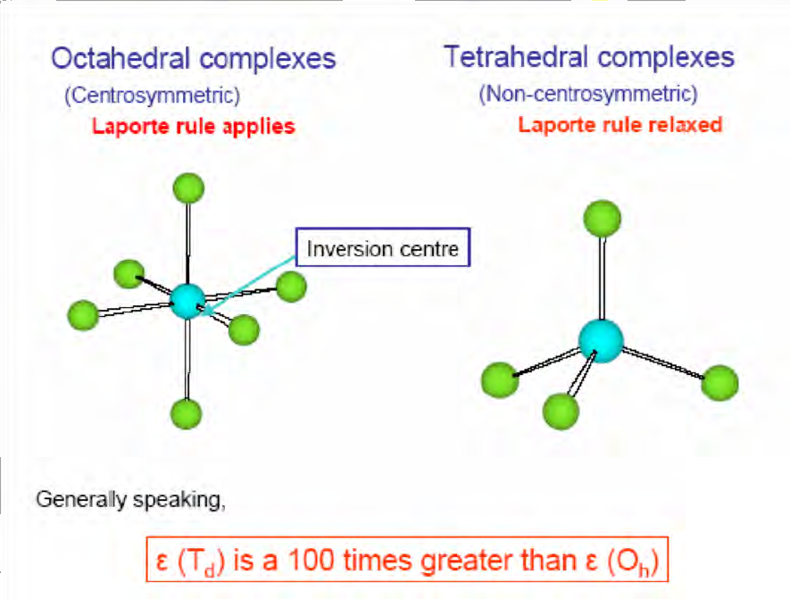
The key element here is that there are mechanisms by which selection rules can be relaxed so that transitions can occur, even if only at low intensities. Unsymmetrical vibrations of an octahedral complex can transiently destroy its center of symmetry and allow transitions that would otherwise be Laporte forbidden. In cases where the rule applies, the colors of the complexes are usually relatively pale. As examples, consider [Cu(H2O)6]²⁺which is a rather pale blue color vs[Cu(NH3)4]²⁺which is an intense dark blue.

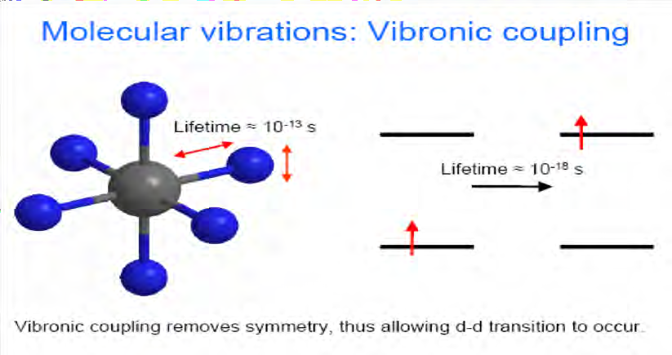

Spin Allowed - Spin Forbidden Any transitionfor which ∆S≠0 is strongly forbidden; that is, in order to be allowed, a transition must involve no change in spin state. Consider the case of the high spin d⁵complex [Mn(H2O)6]²⁺. Electronic transition is not only Laporte forbidden but also spin forbidden. Absorptions that are doubly forbidden transitions are extremely weak. It is understandable, then, that dilute solutions of Mn(II) are colorless.

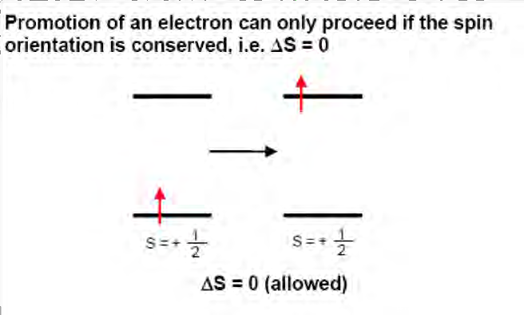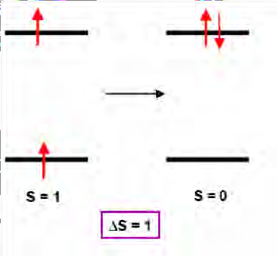

Charge-Transfer (CT) Bands. Similar to d-d transitions, charge-transfer (CT) transitions also involve the metal d-orbitals. CT bands are observed if the energies of empty and filled ligand- and metal-centered orbitals are similar. The direction of the electron transfer is determined by the relative energy levels of these orbitals: i) Ligandto-Metal charge transfer (LMCT) like in MnO₄⁻, CrO₄²⁻ etc. For MnO₄⁻, the d-electron count on Mn(VII) is d⁰. The origin of the color in this species is not due to d-d transition, rather, charge transfer from O²⁻ to Mn(VII), described as LMCT band. ii) Metal-to Ligand charge transfer (MLCT) like in [Fe(bpy)₃]²⁺. In this complex the charge transfer occurs from Fe(II) to the empty π* orbitals of bpy ligand.

